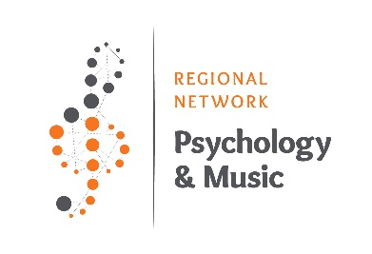

(FOR ENGLISH – SCROLL BELOW)

**Formular za članstvo u Regionalnoj mreži Psihologija i muzika (RNPaM) (članstvo je besplatno)**

Molimo Vas da popunite formular na svom I na engleskom jeziku

|  |  |
| --- | --- |
| Ime i prezime |  |
| Zanimanje/Zvanje/afilijacija*  Studentski status/Institucija* |  |
| Email*  Da li želite da Vaš mejl bude vidljiv na sajtu?* |  |
| Kratak BIO, sa područjima interesovanja, do 250 reči*  Fotografija (neobavezno; dostaviti fotografiju kao odvojen prilog u nekom od formata jpg, png...) |  |
| Link do ličnog ili vebsajta institucije u kojoj ste zaposleni |  |
| **Ostale informacije**  - Preporučite jedan do dva relevantna linka za članove mreže.  - Preporučite događaje/knjige/časopise/osobe koji mogu biti relevantni za članove RNPaM, sa linkovima do sajtova. |  |
| Da li želite da primate informacije o aktivnostima i događajima na e-mail?* |  |

*Obavezna polja

**Formula for the Regional Network Psychology and Music (RNPaM) membership (no fees)**

|  |  |
| --- | --- |
| Name and surname |  |
| Profession/Title/Affiliation*  Student status/Institution* |  |
| Email*  Do you allow your email to be visible on the website?* |  |
| Short BIO, with the main research interest, up to 250 words*  Photo (voluntarily; submit the photo as a separate attachment in one of the formats jpg, png...) |  |
| Link to personal and/or institutional website |  |
| **Other information**   * Could you recommend at least two relevant links referring to psychology, music, and/or related fields? * Would you recommend events/books/journals/people that could be relevant to the RNPaM members? |  |
| Do you want to receive information about RNPaM activities and events related to psychology, music, and related fields?* |  |

*Obligatory fields